|  |  |  |  |  |  |  |  |  |
| --- | --- | --- | --- | --- | --- | --- | --- | --- |
| MAD Project Evaluation 1 – Regular Intake 2021 | | | | | | | | |
| Group Name: | <Add the group name you registered with> | |  |  | Batch: | <Add your Lecture Group> | | |
| Student ID | Student Name | Consistency (Out of 2) | Appropriateness and Professionalism (Out of 3) | Usage of resource manager (Out of 4) | Out of box design ideas (Out of 3) | Report (Out of 8) | Total (Out of 20) | Comments |
| IT19xxxxxx | <student 1> |  |  |  |  |  |  |  |
| IT19xxxxxx | <student 2> |  |  |  |  |  |  |
| IT19xxxxxx | <student 3> |  |  |  |  |  |  |
| IT19xxxxxx | <student 4> |  |  |  |  |  |  |
|  |  |  |  |  |  |  |  |

Git Repository Link:

(If already created)

-------------------For Evaluators use only-------------------------------------------------------------------------------------

Evaluator’s name:

Others:

1. Introduction to the project

Purchasing expensive products for short term use is not a viable option for many people. Therefore, many tend to rent the products when necessary. However, as we all have experienced, finding a product to rent is a tedious task. “Huwamaruwa” is a product rental app focused on Sri Lankan community that connects product owners and customers directly. The main intention of this app is to streamline the product rental process while exposing new opportunities for ordinary people to earn an extra income by renting out the products they own. They can rent out household products under several categories such as electronics, kitchen wares, outdoor tools and books. This app also enables equipment rental shops and individuals to take their operations online with a mobile-first rental solution.

“Huwamaruwa” app allows customers to easily discover products they are looking to rent, see their availability and rental prices through the online store. In order to enable equal opportunities to everyone we are planning to implement, two types of rental products known as Premium and non-premium. As the rental process involves some risk and products should be handled properly, we have implemented premium products category where our service team acts as middle party between customer and the product owner. Moreover, our delivery team picks up the product from the owner and delivers to the customer. The products are carefully inspected before delivering and returning. This ensures the safety of the product and the seller’s lost will be covered in case of product damage. Premium product customers will always get quality products at an extra cost.

Non premium products don’t involve our intervention and seller and buyer should arrange the deal themselves. This category connects both parties directly and we expect this feature may persuade many people to use the app.

Product owners can list the items and send offers to buyer requests. They can also manage all necessary functions such as edit or delete listings. Buyers can rent products, review them or request new products. Once reservations have been made online, premium product customers can pay for their rental through the app. A variety of methods, from credit cards to cash on delivery are supported. Admin functions such as delivery management and customer support are also built into the app.

|  |  |  |
| --- | --- | --- |
| 2. Individual Contribution |  |  |
| IT19xxxxxx - | IT19xxxxxx - |  |
| Product review: | Product rental request management: |  |
| Add, update, delete review | Add a product request, update and |  |
|  | Delete product request |  |
| Delivery management (Admin): |  |  |
| View delivery details | Profile management: |  |
| Update status | Add customers and sellers update and |  |
|  | delete accounts |  |
| Customer service: |  |  |
| Chat with customer support |  |  |
| Listing management (Admin): |  |  |
| Approve/Reject, delete listings |  |  |
| IT19xxxxxx - | IT19xxxxxx - |  |
| Rent products: | Product listing: |  |
| View listings | List new Products |  |
| Submit rental details | Update, delete listing |  |
| Edit rental details |  |  |
| Accept or reject requests | Category management: |  |
| Payment management: | Add, Update, Delete categories |  |
|  |  |
| Add payment details |  |  |
| Cash on delivery status (Premium products): |  |  |
| View and update cash on |  |  |
| delivery status |  |  |

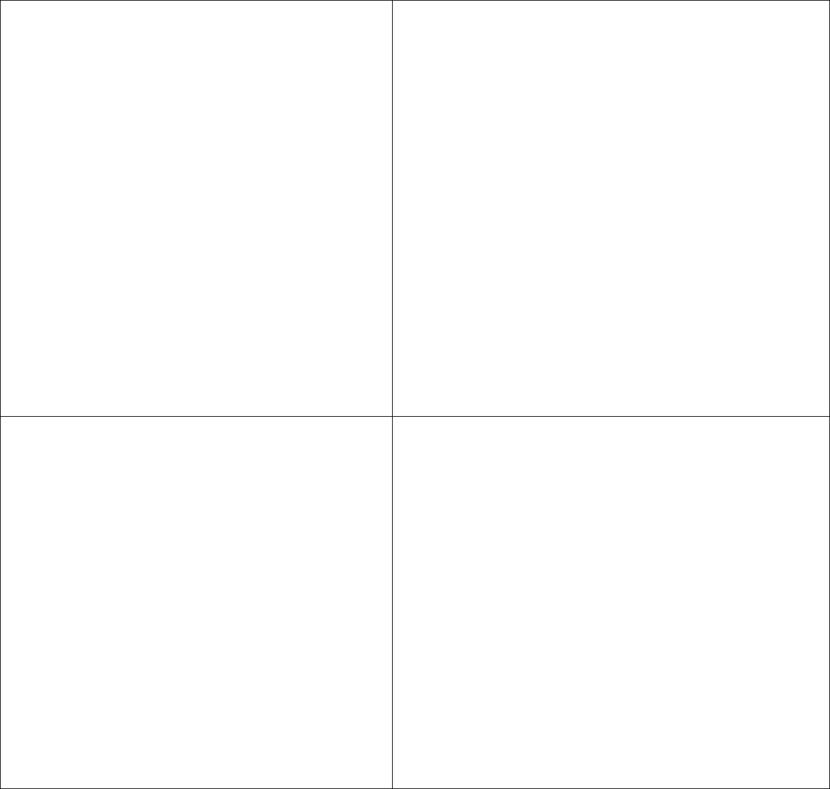

UI Connections

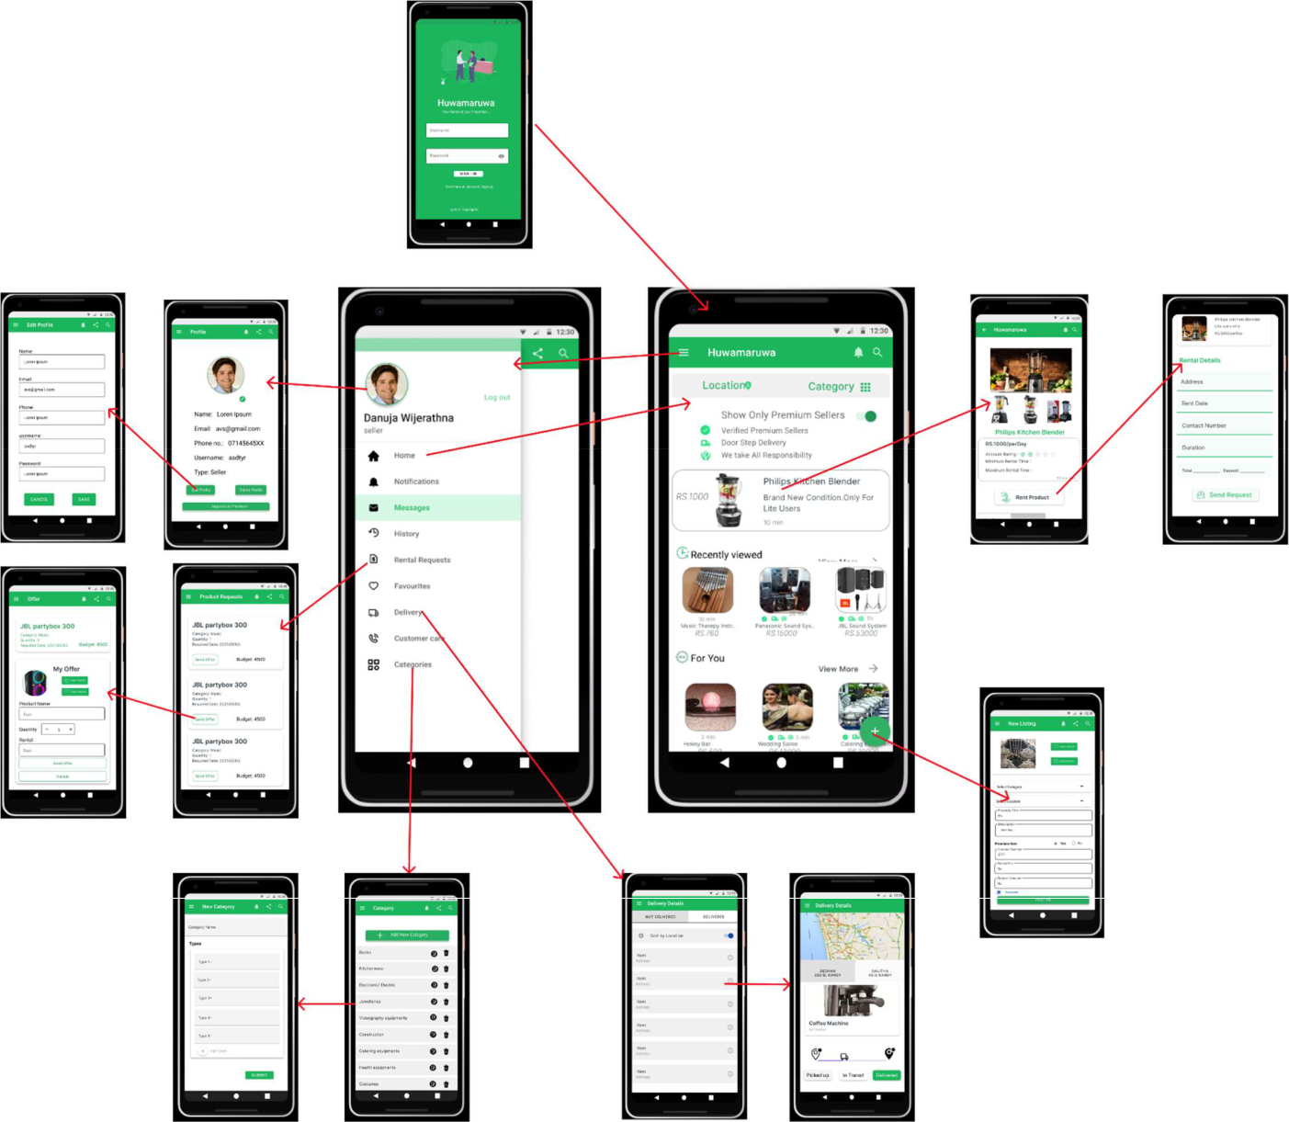

IT19xxxxxx - Product review, Delivery management, Customer Service, Listing management by Admin

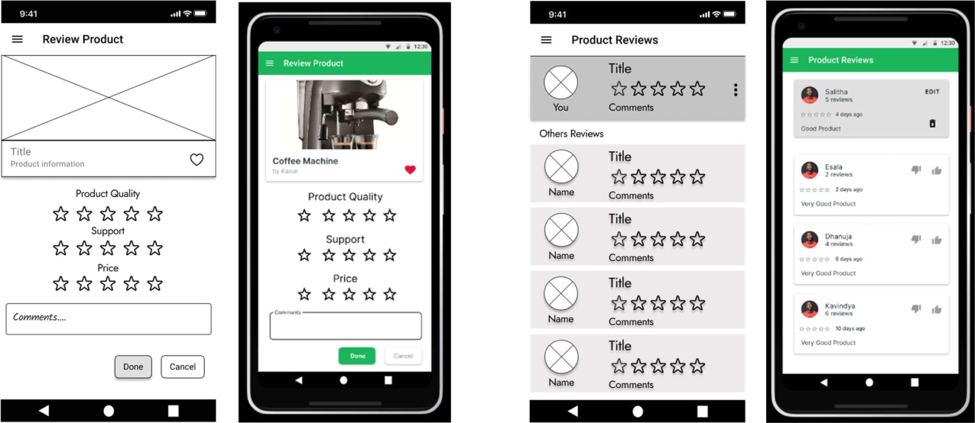

After the product has been successfully returned, a notification is sent to the user asking to review the product. Here, user can rate the product using starts and give a brief description about the experience.

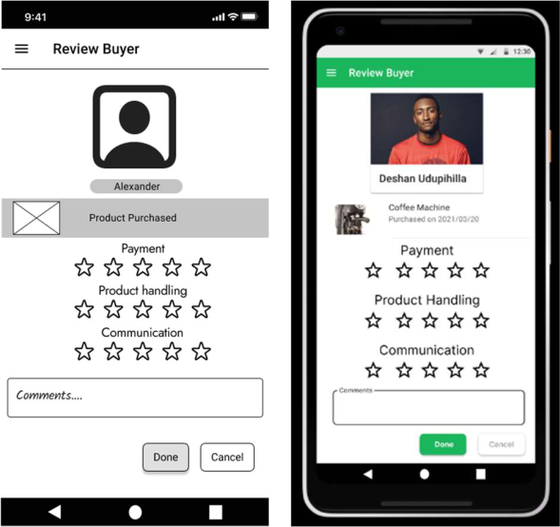

User can view other customers’ reviews on a product and able to edit or delete his/her previous reviews. A pop up appears to conform user cations.

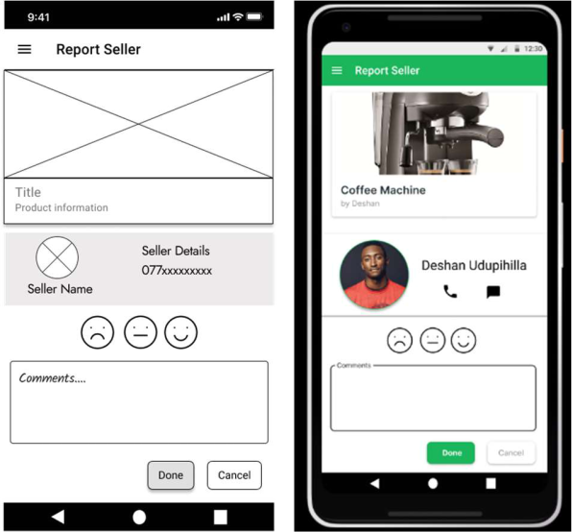

Sellers will also be able to rate the customers by visiting the rate customer section orders section. They can rate using star rating system. Buyer reviews will be displayed in the buyer’s profile and will increase the reputation.

Users can report malicious sellers by clicking the report seller section in the product information page. They can rate the seller as Fine, Bad and Very bad using emoji faces. After that the complaint should be clearly entered in the textbox and click ‘Done’.

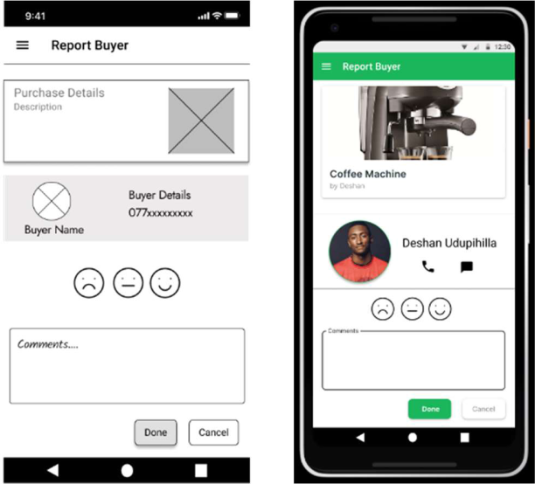

Sellers can report malicious buyers by clicking the report buyer section in the order details page. They can rate the seller as Fine, Bad and Very bad using emoji faces.

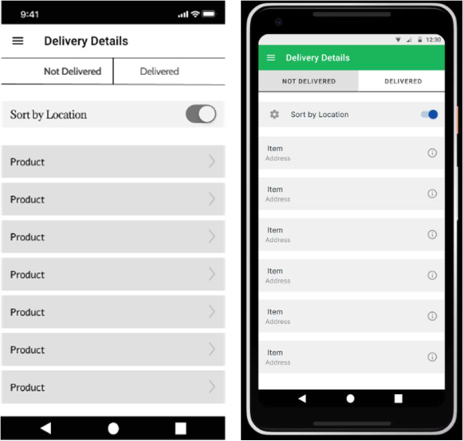

Delivery of the premium product are done by our services team and they can inspect all avilble deliveries through this screen.

Customers can contact support services via chat system build in to the app.

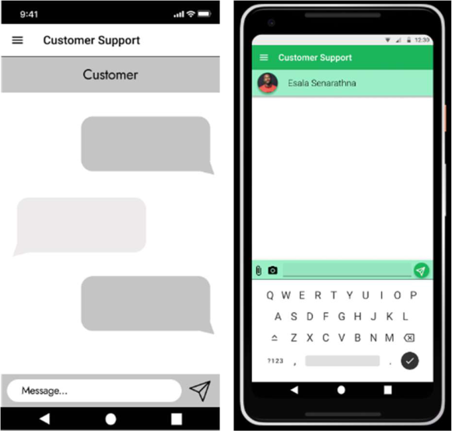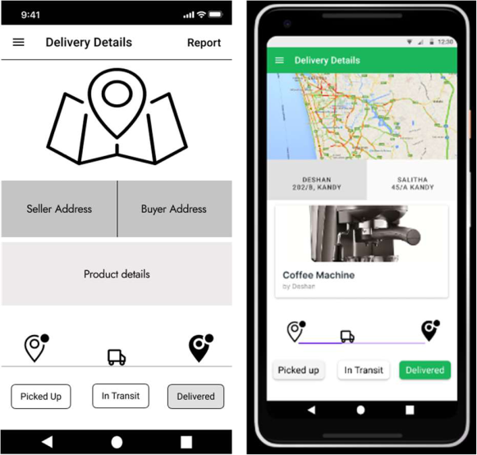

After clicking on an card in delivery details page, this screen appears. Here, they are able to view delivery information and mark delivery status. The map shows the location of the byer and seller uing GPS data making it easier to navigate.

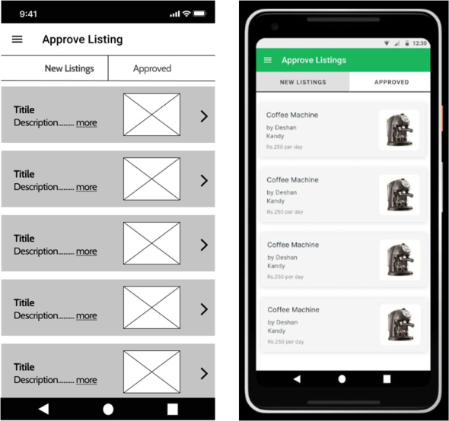

After a seller submit a product listing it should be revied and

After clicking on a lising in ‘Approve Listings’ page this screen

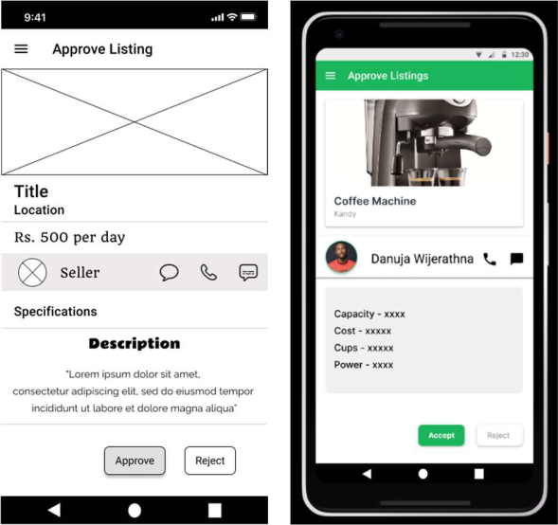

approved by an admin. This screen shows all the available

appears. Here the adminn can view product details and approve or

litings that require approval.

reject it. If approved/rejected, it will be informed to the seler

through a notofication.

Usage of resource files



|  |  |
| --- | --- |
| <resources> |  |
| <string | name="product_review1">Product Quality</string> |
| <string | name="product_review2">Support</string> |
| <string | name="product_review3">Price</string> |
| <string | name="buyer_review1">Payment</string> |
| <string | name="buyer_review2">Product Handling</string> |
| <string | name="buyer_review3">Communication</string> |
| <string | name="btn_done">Done</string> |
| <string | name="btn_cancel">Cancel</string> |
| <string | name="btn_edit">Edit</string> |
| <string | name="txt_review">reviews</string> |
| <string | name="txt_location_sort">Sort by Location</string> |
| <string | name="btn_pick">Picked Up</string> |
| <string | name="btn_intransit">In Transit/string> |
| <string | name="btn_delivered">Delivered</string> |
| <string | name="txt_notdelivered">Not Delivered</string> |
| <string | name="txt_newlistings">New Listings</string> |
| <string | name="txt_approved">Approved</string> |
| <string | name="txt_perday">per day</string> |
| <string | name="btn_accept">Accept</string> |
| <string | name="btn_reject">Reject</string> |
| </resources> |  |



<resources>

<color name="black">#FF000000</color>



<color name="white">#FFFFFFFF</color>



<color name="theme_green">#1BB55C</color>

<color name="card_ash1">#F0F0F0</color>



<color name="card_ash2">#F5F5F5</color>

<color name="card_ash3">#E0E0E0</color>



<color name="chat_bar">#9BEFC7</color>

<color name="purple">#6200EE</color>



</resources>

CRUD Operations and functionality of the components:

After successfully returning the product, a notification is sent to the customer to review the product. Customer can rate the product using star rating system and comment down their experience. Product reviews are shown in the product information page to help new customers discover quality products. Customers can update or delete their previous reviews when necessary.

Upon successful return of the product, the sellers are also presented with a notification to review the buyer. Sellers can rate the customers using star rating system and additional comments if necessary. Customer reviews are shown in customer profile to help sellers avoid scammers. The sellers can update or delete the reviews.

Customer support service is provided through the app as a chat system. Buyers and product owners can contact customer support agents through the built-in chat system. Both parties can edit and delete their conversations.

After submitting a listing, an admin should inspect and approve the listing before appearing in the products page. Here, an admin can update, delete, accept or reject listings. According to our system, Premium products are delivered by our delivery team. The delivery agents can find delivery information within the app. They can update delivery status and find locations of the buyer and product owner using the map. The customer and the product owner get notified about the delivery status.

Material design guidelines are fallowed throughout the app. Linear layout, constrained layout and relative layout are used to arrange the components. Since most of the data are fetched from the database recycler view is used to display list data. Tabs are used to display relevant data in the same page. Toast, pop up alters, and push notifications are used to send important messages to the user.

IT19xxxxxx - Product request and customer and seller management

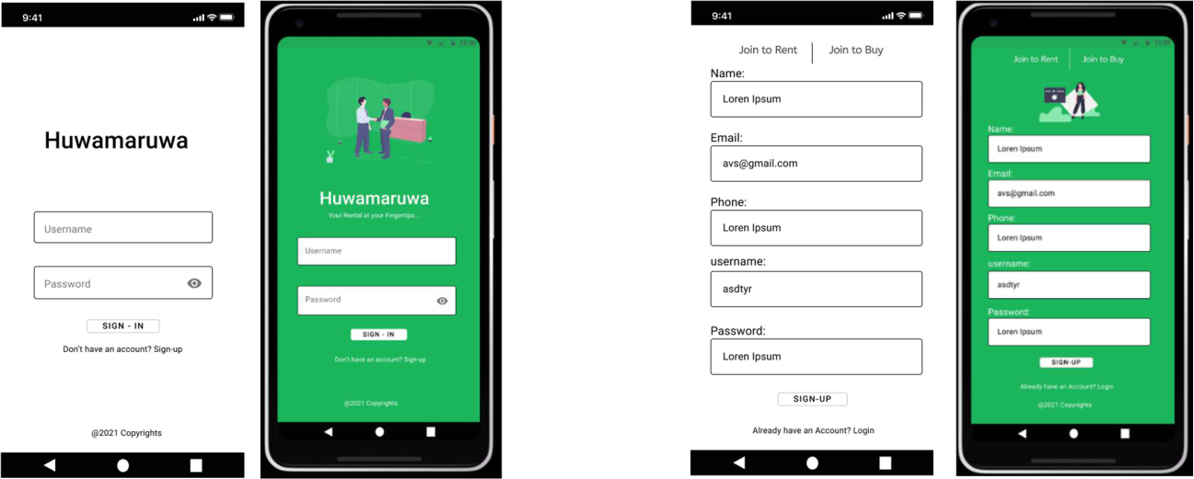

This is the initial page where the customer lands when he loads the app

If a new member wants to join to the ap he or she has to fill the form and sign up

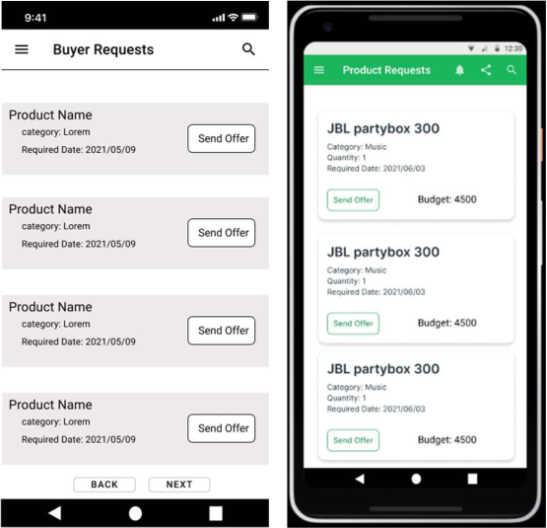

This the UI where the product requests from the clients are displayed for the sellers. So by browsing here they can select a product and send their offer for it.

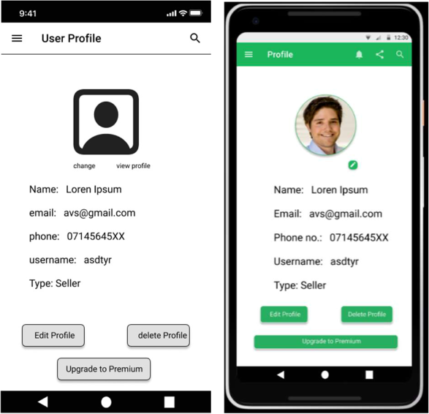

This is the UI where app members can see their user profiles. Here a ember is given options to delete and update their user profiles.

For a product requested by a client their can be many offers. So these offers for a certain product is shown in this interface.

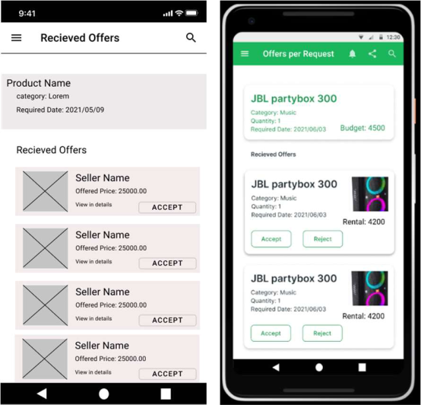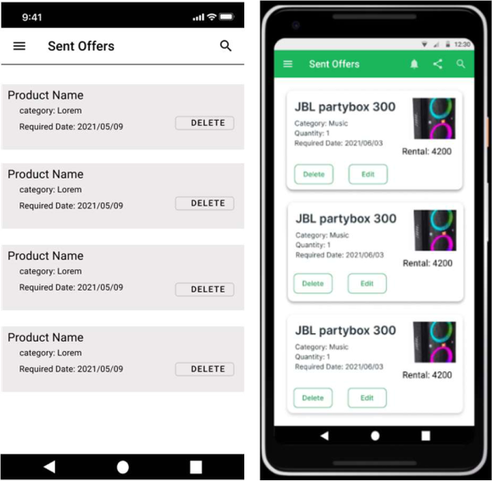

Their can be multiple offers sent to many product requests by a certain seller. These offers are shown in this page.

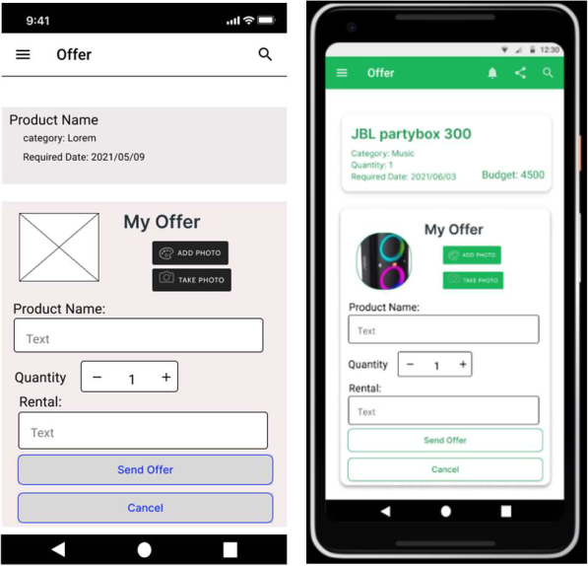

When a seller selects send offer of a certain product request, the seller is directed to this page.

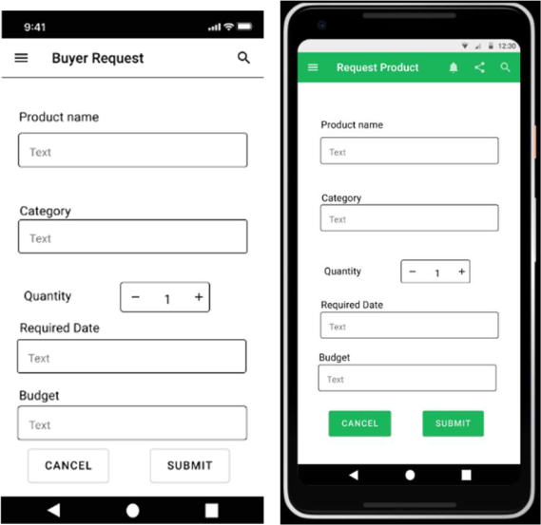

This is the initial UI where a customer can add a product request.

This is the UI where a customer or a client gets to update a user profile.

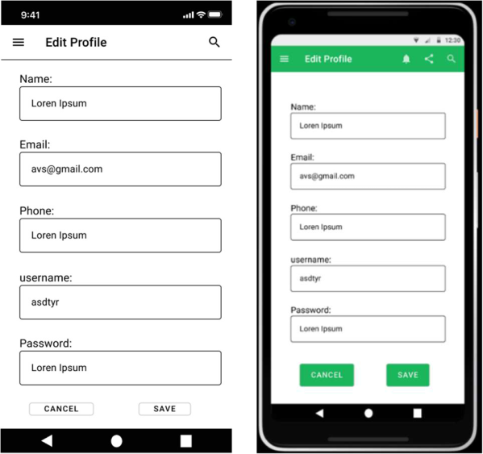

Usage of resource files.

<resources>



<string name="app_name">Huwamaruwa</string>



<string name="lblproductName">Product Name</string>



<string name="lblCategory">Category</string>



<string name="lblQuantity">Quantity</string>

<string name="lblRequiredDate">Required Date</string>



<string name="lblBudget">Budget</string>



<string name="lblSave">Save</string>



<string name="lblCancel">Cancel</string>



<string name="btnsignUp">Sign up</string>

<string name="btnsignIn">SignIn</string>



<string name="lblAlreadyHaveAnAccount">Already have an Account?</string> <string name="lbldonthaveanAccount">Don\'t have an Account?</string> <string name="lblMyOffer">My Offer</string> <string name="lblRental">Rental</string>



<string name="btnDelete">Delete</string>



<string name="btnEdit">Edit</string>



<string name="lblEditProfile">Edit Profile</string> <string name="lblRequestProduct">Request Product</string> <string name="lblProductRequest">Product Request</string> <string name="lblProfile">Profile</string> <string name="btnAccept">Accept</string>



<string name="btnReject">Reject</string>



<string name="btnEditProfile">Edit Profile</string>

<string name="btnUpgradeToPremium">Upgrade To Premium</string> <string name="btnSubmit">Submit</string>



</resources>



<resources>



<color name="greenBackgrouns">#1BB55C</color> <color name="black">#FF000000</color> <color name="white">#FFFFFFFF</color>



</resources>

CRUD operations and the entire functionality of the component:

Our system consists of a implementation where a customer can request for a new product of if he needs to check many listing related to the product that he need, there is interface in our system where he can request the product he need to rent. Once this product is requested it is shown for the sellers in the system. So, they can send offers for the product listed in that page. So in order to send a offer the sellers are given an interface. The customer can see the offers which have been sent to their request. So, from the requests he or she can select a product and rent the product. At this point a notification to the relevant system is sent by them

When a product rental request is sent by a customer there is also an option to edit that request later and also if he wants the request can also be deleted also. And when a seller send an offer for a request he is also given the opportunity to delete and update his request.

There is also a section of customer and seller management where the details related to their profiles can be updated or deleted

When deciding colors to the layouts we focused on the color balancing. And for the UI components I used menu bars and layouts to separate sections of the UI. In most UI the recycler view layout used for listing views as we can limit he retrieval from the database. As as it is a mobile app we didn’t implement pop ups instead of that we intend to have toasts in situations where necessary.

IT19xxxxxx - Product Rental and Payment Management

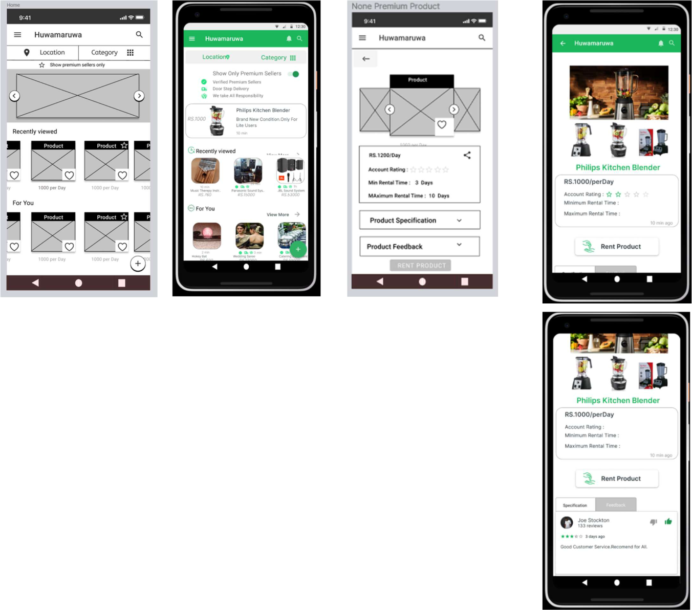

This is the Main view. After

customer login he/she

redirect to this view.

When customer select some

non-premium rental Item then

he redirects to this view.

Using this view, he can view all

the product details

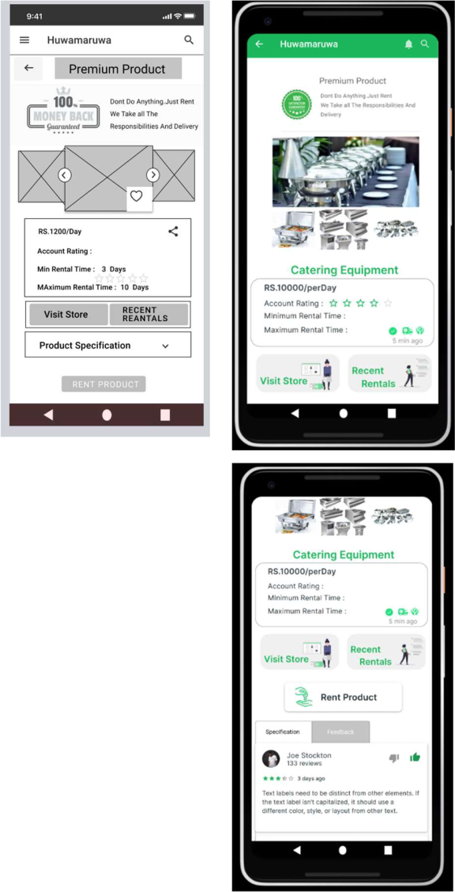

When customer select premium rental Item then he redirects to this view.

Using this view, he can view all the product details

If customer select Rent Product Button in Non-Premium product, Then He redirect to this view.

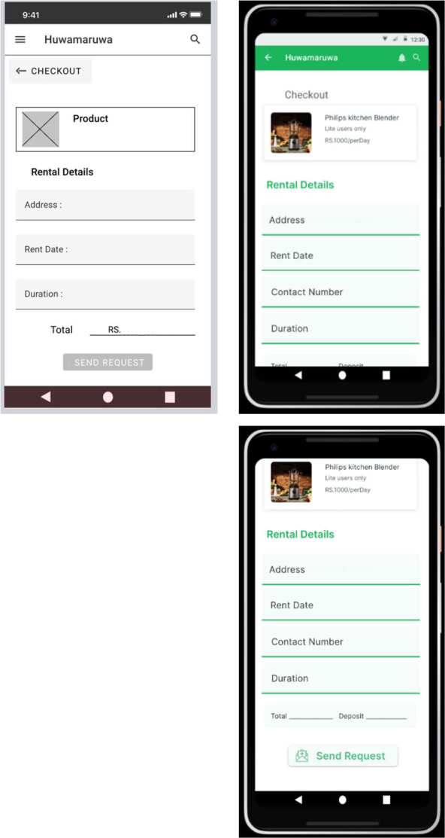

In This view He must fill all the data and send request to the product owner.

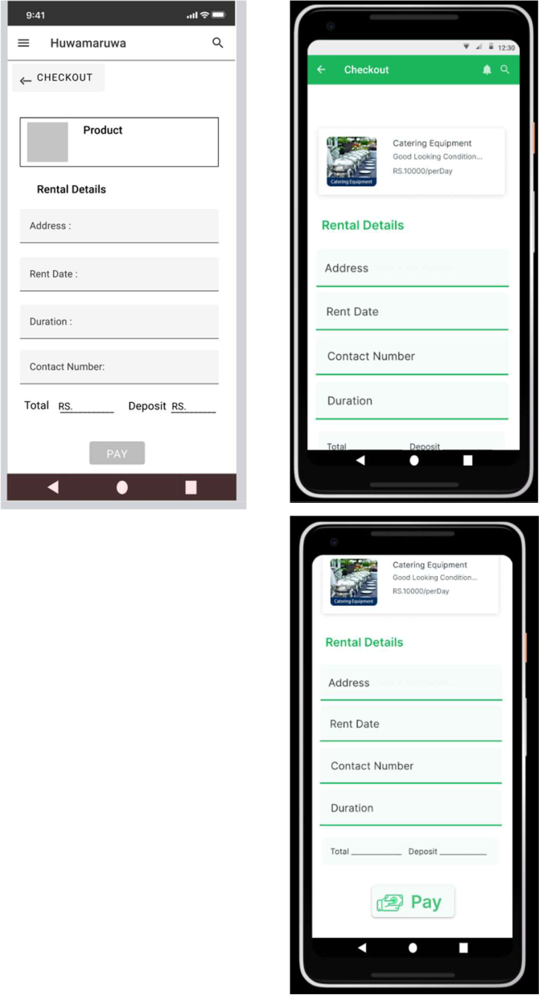

If customer select Rent Product Button in Premium product Then He redirect to this view.

In This view He must fill all the data and select Pay option

When customer send the

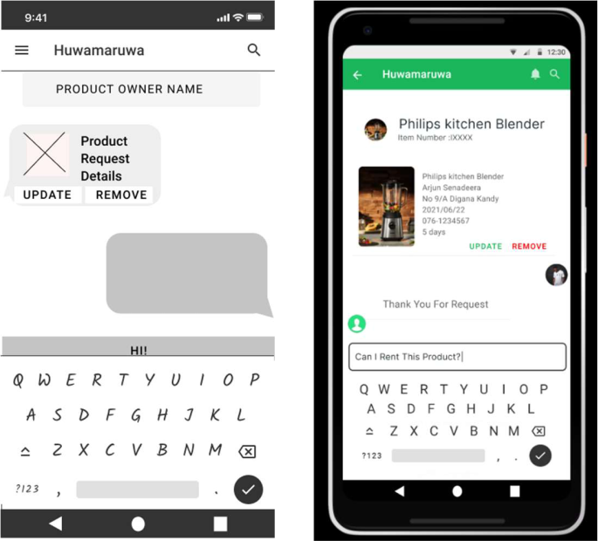

Request then, between

customer and product owner

open a chat session and

display the request here.

In there both can update and

remove the request.

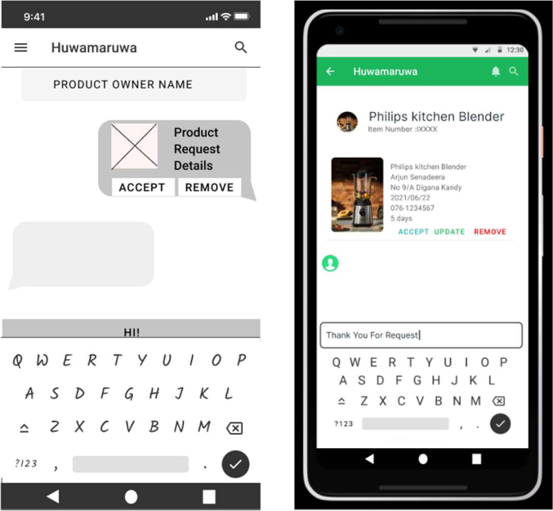

Product owner can accept the

request.

When customer Select Pay

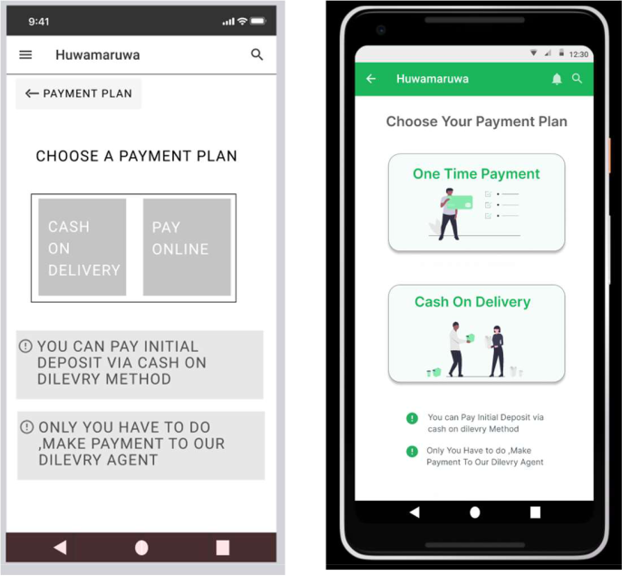

option, he/she redirect to this

view.in this views he can

choose his payment method. If

it is onetime payment, then he

can add card details.

If it is a cash on delivery the

status update in delivery page.

Usage of resource files



<resources>



<string name="app_name">My Application</string>

<string name="showOnlyPremiumRentals">show Only Premium Rentals</string> <string name="location">Location</string> <string name="category">Category</string>



<string name="vrfyPremiumRentals">Verify Premium Rentals</string> <string name="doorStpDelivery">Door Step Delivery</string>



<string name="weTkeResponsibility">We Take All Responsibility</string> <string name="recentView">Recently Viewed</string> <string name="viewMore">View More</string>



<string name="forYou">For You</string>

<string name="rentProduct">Rent Product</string>



<string name="specification">Specification</string>



<string name="feedback">FeedBack</string>

<string name="premiumProduct">Premium Product</string>



<string name="premiumProductDescrip">Dont Do Anything.just Rent ,We take all the Responsibilities and Delivery</string>



<string name="visitStore">Visit Store</string>

<string name="recentRentals">Recent Rentals</string>



<string name="checkouts">Checkout</string>



<string name="rentalDetails">Rental Details</string>

<string name="address">Address</string>



<string name="rentDate">Rent Date</string>

<string name="contactNumber">Contact Number</string> <string name="duration">Duration</string>



<string name="total">Total</string>



<string name="deposit">Deposit</string>

<string name="pay">Pay</string>



<string name="chooseYourPaymentPlan">Choose Your Payment Plan</string> <string name="oneTimePayment">One Time Payment</string>



<string name="cashOnDelivery">Cash On Delivery</string> <string name="sendRequest">Send Request</string> </resources>



<resources>



<color name="purple_200">#FFBB86FC</color>

<color name="purple_500">#FF6200EE</color>



<color name="purple_700">#FF3700B3</color>

<color name="teal_200">#FF03DAC5</color>



<color name="teal_700">#FF018786</color>



<color name="black">#FF000000</color>

<color name="white">#FFFFFFFF</color>



<color name="GreenMain">#1BB55C</color>

<color name="lightGreenBtn">#F6FCF9</color>



<color name="lightGrayBtn">#F0F0F0</color>

<color name="btnBlue">#1BB5AC</color>



<color name="btnRed">#EE0000</color>



<color name="vetorGreen">#88E9AF</color>

</resources>



CRUD Operations and functionality of the components:

My part in our mobile is product rental and payment handling.

Component & principals

I basically used unique and be focused mobile mindset principals to all these views. Guidelines such as responsive and scroll are also used. It also receives feedback and sends confirmation alerts under communication. I’m also used various icons and vector arts to get a good first impression (resources -undraw.co, icons8.com). Speaking of mobile components, I’m used the toast component for various confirmations and alerts. Also used various buttons and a text field. Also uses linear layout and recycler views for the Main page. Other pages also use a relative and constraint layout.

Crud operations

Here I will get the required data from our database and create a visible view to the customer who comes to get rent. Then I will create a view that shows the details of an item after he has selected it. It also a data retrieve part. When he clicks to rent the product, he gets to fill in a form containing the details. in that form calculate and display the total amount and deposit amount.

After submitting this form, the data is saved in our database. There are basically two parts to these products, Namely premium production, and non-premium product. If a non-premium product is selected here, the person who owns the product will receive the request through a chat after filling the above-mentioned form. The person who owns the item can then accept or remove the request. If removed in this way, the request will be deleted from the database. The person who wants the item can also contact the product owner via this chat service to know some issues and edit or delete the request they sent.

If he chooses a premium product, we will take full responsibility for it, and the chat service will not contact the owner of the product. Instead, it takes him to the payment plan view.

He can make an initial payment online through the one-time payment method or make the initial payment to our agent through cash on delivery. The all the status of that cash-on-delivery service will be updated in our database.

IT19xxxxxx – Product listing and Category Management

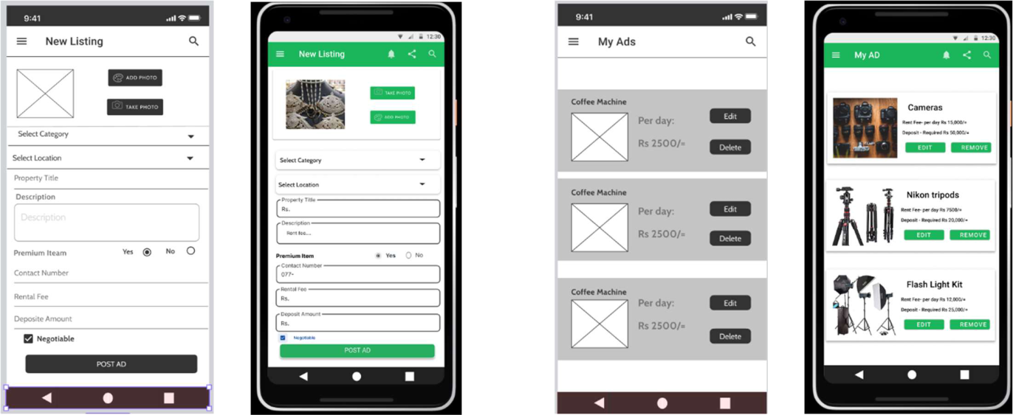

If the user wants to post an AD about his rental goods. For that he/her need to fill this form.

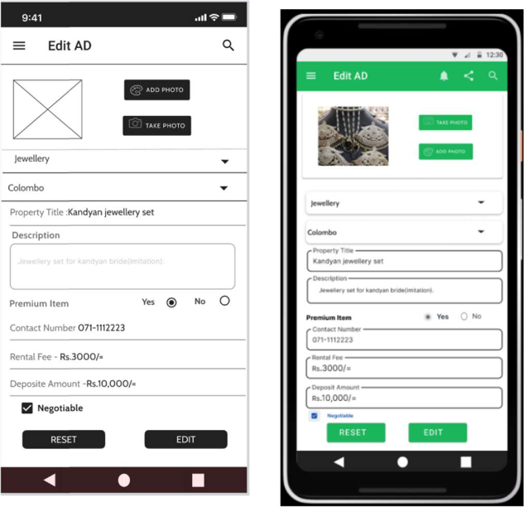

Then he/she can see all the ads published by him here. He can make changes to the ads he has posted or remove those ads if he so wants.

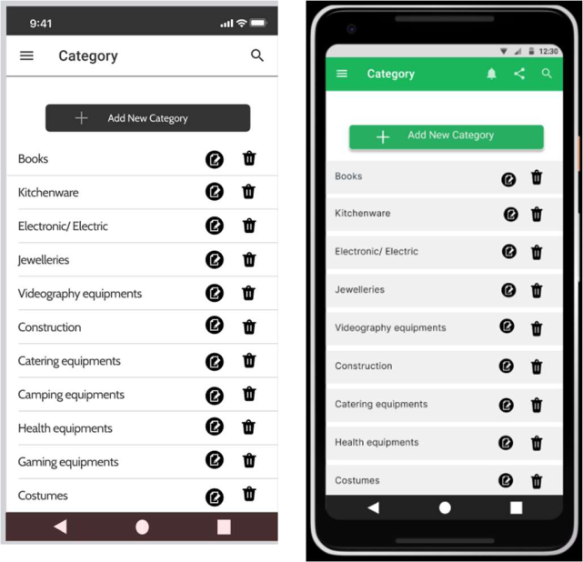

When the user clicks the edit button on the previous page, the user will come to this page. If the user wants to make any changes to the ad on this page, they can do so.

Admin can add a new category through this page and delete, edit and view the existing category.

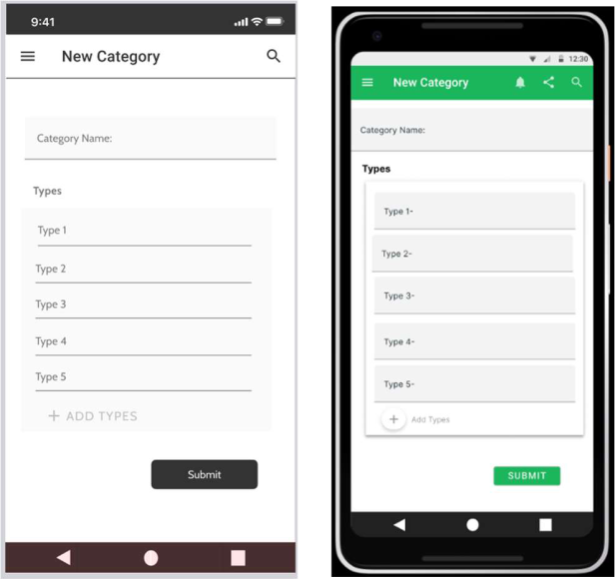

From this page, the admin can add a new category to the app. Relevant information should be included in this form when adding a new category.

That should include the title of the category and the types of subcategories.

Clicking on the edit button on the previous page brings the user to this page. This allows the admin to update existing category data if desired and add or subtract new subcategories.

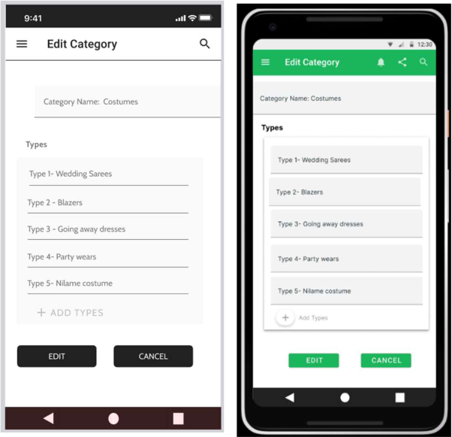

Usage of resource files



<resources>



<string name="app_name">Post AD</string>



<string name="select_category">select Category</string> <string name="select_location">select Location</string> <string name="Property_Title">Property Title</string> <string name="description">Description</string> <string name="contact_number">Contact Number</string> <string name="Rental_fee">Rental Fee</string> <string name="deposit_Amount">Deposit Amount</string> <string name="addPhoto_btn">ADD PHOTO</string> <string name="takePhoto_btn">TAKE PHOTO</string>



</resources>



<resources>



<color name="greenBack">#1BB55C</color>



<color name="black">#FF000000</color>



<color name="white">#FFFFFFFF</color>



</resources>

CRUD operations and the entire functionality of the component

The principles and components I used are focused, unique, charming in the mobile mindset. I have used components called responsiveness and contents of global guidelines principles. I also used components such as confirmation, alert, keyboard variation in the principles of user inputs and communication. I also used different icons for this. They are icons8.com. I also used various buttons and a text field.

In this project my part is category management and product listing. Collect the rented products data from the forms' filled by suppliers and add them into the product list. There is an option to the suppliers to view all the previous advertisements which were posted by them on the website. By that option they can change the details of the advertisements or remove them from the site. Admin could be able to add new categories to the website and there is a form to input their details to the site. There also admin can view the previous categories and change them according to his /her needs and also can remove it too.